

**COMSATS University Islamabad, Pakistan**

**Online Case Filing System**

**By**

**Malik Ameer Hamza CIIT/FA17-BCS-039/ATK**

**Syed Qammer Abbas CIIT/FA17-BCS-030/ATK**

**Supervised By**

**Mr. Shahzad Rizwan**

**Bachelor of Science in Computer Science (2017-2021)**

**The candidate confirms that the work submitted is their own and appropriate**

**credit and appropriate credit has been made to the work of others.**



**COMSATS University Islamabad, Pakistan**

**Online Case Filing System**

**A project presented to**

**Comsats University Islamabad, Attock Campus**

**In partial fulfillment**

**of the requirement of the degree of**

**Bachelor of Science in Computer Science (2017-2021)**

**By**

**Malik Ameer Hamza CIIT/FA17-BCS-039/ATK**

**Syed Qammer Abbas CIIT/FA17-BCS-030/ATK**

**DECLARATION**

We hereby declare that this software, neither whole nor as a part has been copied out from any source. It is further declared that we have developed this software and accompanied the report entirely based on our efforts. If any part of this project is proved to be copied out from any source or found to be a reproduction of some other. We will stand by the consequences. No portion of the work presented has been submitted of any application for any other degree or qualification of this or any other university or institute of learning.

Malik Ameer Hamza Syed Qammer Abbas

--------------------------- ---------------------------

**CERTIFICATE OF APPROVAL**

It is to certify that the final year project of BS (CS) **“Online Case Filing System”** was developed by **Malik Ameer Hamza (CIIT/FA17-BCS-039/ATK)** and **Syed Qammer Abbas (CIIT/FA17-BCS-030/ATK)** under the supervision of **“Mr. Shahzad Rizwan”** and that in his opinion; it is fully adequate, in scope and quality for the degree of Bachelors of Science in Computer Sciences.

-------------------------------------------------------

**Supervisor**

-------------------------------------------------------

**External Examiner**

----------------------------------------------------

**Head of Department (Department of Computer Science)**

**Acknowledgment**

All praise is to Almighty Allah who bestowed upon us a minute portion of His boundless knowledge by virtue of which we were able to accomplish this challenging task.

We are greatly indebted to our project supervisor “Mr. Shahzad Rizwan”. Without his supervision, advice, and valuable guidance, completion of this project would have been doubtful. We are deeply indebted to them for their encouragement and continual help during this work.

And we are also thankful to our parents and family who have been a constant source of encouragement for us and brought us the values of honesty & hard work.

Malik Ameer Hamza Syed Qammer Abbas

--------------------------- ---------------------------

**Table of Contents**

CHAPTER 1 8

INTRODUCTION 8

Introduction: 9

Brief: 9

Relevance to course modules: 10

Project Background: 10

Literature Review: 11

Methodology and Software Lifecycle: 11

The rationale behind the selected methodology: 12

CHAPTER 2 13

PROBLEM DEFINITION 13

Problem Statements: 14

Deliverables and Development Requirements: 14

CHAPTER 3 16

REQUIREMENT ANALYSIS 16

Requirement Analysis: 17

Functional Requirements: 17

Non-Functional Requirements: 17

CHAPTER 4 19

DESIGN ARCHITECTURE 19

Project Design: 20

Use Case Diagram: 20

Activity Diagrams Case Filer: 21

Context Diagram: 24

**Table of Figures:**

Figure 1 Iterative Model 12

Figure 2 Use Case Diagram 20

Figure 3 Activity Diagram of Case Filer 21

Figure 4 Activity Diagram of Judge 22

Figure 5 Activity Diagram of Admin 23

Figure 6 Context Diagram 24

# 

# CHAPTER 1

# INTRODUCTION

**INTRODUCTION:**

Our project “Online Case Filing System” is basically an online platform where everyone will be able to file the case. This is a very unique kind of project and there is a need for this type of project as well because there are a lot of difficulties and problems in manual (current) case filing system. And manual case filing system takes a lot of time too.

For using our system and filing the case, the user just needs to sign up. And then login to his/her account. After login, the user will be able to file the case. The user will provide his/her personal information and then the user will select the category of the case ((e.g. Criminal case, family case etc.) .After selecting the case category, the user will upload the case documents in the form of pdf and will submit the case. The case will now go straight to the head judge of the particular court (e.g. if the case that is being filed is a family case, then the case being filed will go to the head judge of the family court). Now the system will notify the judge about the filed case through Email. The judge will also need to login to his/her account to see the cases (either new or previous cases); the cases will be shown to the judges in priorities means there will be high or low priority cases. Now it’s up to the head judge of the court that does he want to keep the new case or sent to his subordinate judges. If the judge wants to transfer the case, the system will sent the case to that subordinate judge. Now the date of case hearing will be given to the case filer and the case filer will see this information through his account. And the user can also check the other case related information online like the date of case hearing, which judge is dealing with our case, next hearing date of the case, decision of the case and other information. And when the case is decided, the judge will write the final comments and will declared the case as decided case then the case will be shown in the category of decided cases.

Through our Online Case Filing System, we can keep track of the progress of all the courts. Because our portal is not only limited to one or two courts but it can also cover all the courts of a district. So we can track the progress of all the courts of a district. Progress like how many cases are filed in a day in all the courts, how cases are pending in each court, how many cases are decided today or in this week or in this month, which court is performing very good or bad etc. And we can also generate the report of the progress of the courts as well.

Another functionality that our project will provide is the recommendation of lawyers. Our system will recommend the best lawyers to the case filers on the basis of location of the lawyer near to the user, fees range, win cases, case specialty, and behavior with the client etc.

**BRIEF:**

Online Case Filing system is a web based system developed by using the Html, Css and C# languages. It has the following goals:

**1.** First of all to give facility to anyone/lawyer that they can file the case online.

**2.** Secondly to save everyone’s time by applying for the case online instead of going to the courts physically and face a lot of disgrace and waste a lot of time.

**3.** Thirdly our system will recommend the best lawyers to the case filers according to the case category.

**4.** Fourthly to provide such kind of online portal in which for filing any case, the lawyer/anyone does not need to go to the courts but they will be able to submit their case related documents easily in the form of pdf and can also get rid of the paper work.

**5.** Fifthly to make such kind of online system in which a person who will file the case will get the case related information/updates online.

**6.** Lastly to keep track of the progress of all the courts like how many cases are filed in a day in all the courts, how cases are pending in each court, how cases are decided today or in this week or in this month, which court is performing very good or bad etc.

## 

## Relevance to course modules:

**Web Technologies:** In the course of Web Technologies, we have studied about the Html and Css languages that will us in the designing of this project.

**Report Writing Skills:** This course is about learning how to write reports and other formal documentation and in our project we need to write our documentation so this course is helping a lot in this task.

**Visual Programming:** In the course of Visual Programming, we have studied the C# language that will help us in the development of the project.

**Human-Computer Interaction:** An interactive system is easy and comfortable for the user to use the system and understand it easily and this course is all about designing an interacting system following standard rules.

**Project Background:**

The main idea behind this project is that the current process of case filing is very time taking and very disgraceful and a lot of time is being wasted in the physical involvement of case filing and also it is a difficult job to find the best lawyer. And there is a lot of paper work required for case filing and sometimes when someone submits the case documents in the court, those documents get lost/missed by the court and then we have to submit them again. And also that there is no such mechanism through which the case filer can get the information about his/her filed case like the date of case hearing, which judge is dealing with his/her case, next hearing date of the case, decision of the case and other information. And there is no such online system in which we can keep track of progress of all the courts in one place.

So there was a need for such a system through which we can file the case easily and can find the best lawyer around the user based on various factors and can get rid of the paper work and through which we can upload the case related documents and can check the case related information/updates online and keep track of all the progress of all the courts in one place.

**Literature Review:**

A literature review surveys books, scholarly articles, and any other sources relevant to a particular issue, area of research, or theory, and by so doing, provides a description, summary, and critical evaluation of these works in relation to the research problem being investigated. In literature review we make a comparison of our project with the existing projects and compare the pros and cons of existing projects with our project.

So we have done a lot of research on Online Case Filings Systems of the world and it turns out that the online case filing system is only fully operational in UK, which is called E-Filing. After understanding E-Filing, it was discovered that it lacked something’s.

First of all, E-Filing does not recommend the lawyer but our Online Case Filing System provides the facility of lawyer recommendation to the users. A good lawyer is needed to win a case so our system recommends the best lawyer to the user on the basis of location of the lawyer near to the user, fees range, win cases, case specialty, and behavior with the client etc.

Secondly E-Filing does not have case transferring facility but in Online Case Filing System when the head judge of a court receives a new case and if the head judge does not want to keep the case and wants to transfer it to his/her subordinate judge, the system allow the head judge to transfer the case.

## 

## Methodology and Software Lifecycle:

We use the iterative approach to develop this application. The iterative method is a way to breakdown the development process into small patches so that instead of developing the whole software at once which is difficult to develop, we develop in small steps.

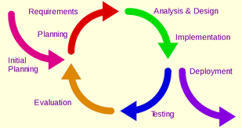

**Figure 1 Iterative Model**

### The rationale behind the selected methodology:

The iterative process is the way to breakdown the whole process into smaller chunks in order to develop the complete software in one go. The reason behind this approach is that it is easily measurable and small chunks are easy to test and debug as compare to developing the whole software and then testing it, at this point debugging becomes difficult.

# CHAPTER 2

# PROBLEM DEFINITION

**Problem Statement:**

Everyone has to go to the court at some point in their lives for case filing. So while filing the case they face a lot of difficulties like:

•While filing the case by physical involvement the thing we face the most is the disgrace. When a person who files the case first time in his/her life, he does not know what are the platforms, where he/she can go and file the case. And for finding the right way he/she faces a lot of disgrace.

•For filing the case for example for the first time in life a person does not know what are the documents that are needed for the case to be filed and where to submit these documents for the case filing?

•When a person/lawyer submits the case documents in the court, sometimes those documents get lost/missed by the court and then we have to submit them again. This process takes a lot of extra time and effort.

• Finding the best lawyer manually is another difficult task.

• When anyone or his/her lawyer file the case by going physically to the courts it takes a lot of time because firstly the lawyer will complete the documents that will be necessary for the case and then he/she will go to the courts and submit the documents and after that the judge will read the documents and then will give the date for the case hearing.

•There is no such platform through which the case filer can get the case related information like the date of case hearing, which judge is dealing with our case, next hearing date of the case, decision of the case and other information.

## Deliverables and Development Requirements:

Following is the list of deliverables of our project:

* Admin
* Case filer’s profile
* Lawyers profiles
* Judges profiles
* Recommend lawyers
* Case filing system
* Email Notifications
* Updates of filed case’s
* Generate progress reports

Development requirements include the following software requirements:

* IDE : Visual Studio , Sql Server
* Database: MySQL
* Programming Languages: Html, Css, C#

# CHAPTER 3

# REQUIREMENT ANALYSIS

## 

## Requirement Analysis:

Software Requirement Analysis (SRS) is not an ordinary document because it provides a basic understanding of functional as well as non-functional requirements. We can consider it as the starting point of the project because it serves as a written contract between the client and organization about the features and the functionalities of the project. With the help of SRS, both the clients and organizations make clear to each other about the deliverable project.

**Functional Requirements:**

Functional requirements are the description of the service that the software must offer. It describes a software system or its component. A function is nothing but inputs to the software system, its behavior, and outputs. It can be a calculation, data manipulation, business process, user interaction, or any other specific functionality which defines what function a system is likely to perform.

Functional requirements of our project are as follows:

**Filing the Case:**

Case filing system provides the functionality of case filing to the users. For filing the case the user needs to first get registered with our system and then login to his/her account and then the user will be able to file the case. For Case filing, the user needs to provide the basic information and select the case category (e.g. Criminal case, family case etc.) And the user needs to upload the documents in the form of pdf.

**Getting Updates:**

Once the user successfully files the case, the user must get all the case related information for example the information of the date of case hearing, which judge is dealing with his/her case, next hearing date of the case, decision of the case and other information. The user will be able to get the above information through his/her dashboard that can be seen after logging in to his/her account.

**Lawyers Recommendation:**

Our project “Online Case Filing System” also provides the lawyer recommendation functionality to the users. Our system not only allows the user to file the case but also it recommends the best lawyers around the user.

**Non Functional Requirements:**   
The non-functional requirements describe how the system should work. It also specifies the quality attribute of a software system. They judge the software system based on Responsiveness, Usability, Security, Portability and other non-functional standards that are critical to the success of the software system.

Following are the non-functional requirements of our project:

**Performance:**

**Performance** describes the efficiency of the system. Our project will be very good in performance like it will file the case in a short period of time and then the case will be sent to concerned judges quickly.

**Portability:**

Portability means that the user must not be restricted to use the application in a specific area/place. Our web application is very portable because it allows the users to use it everywhere.

**Usability:**  
Usability means that the application should be easy to use. The user should not feel any difficulty in using this system. In our project of “Online Case Filing System”, it is very easy for the user to file the case and check the case updates and there is nothing difficult in it.

**Compatibility:**

Compatibility is described as the user can use the application in all the devices and it must not be restricted to some specific devices. Our web project is very compatible with all the devices and it can run on every browser.

**Security:**

Security is one of the most important factors in the project that must not be compromised at any cost. In our project all the data is safe and secured. All the information that a user gives is completely secured.

# CHAPTER 4

# DESIGN ARCHITECTURE

**Project Design:**

Project design is an early phase of the project where a project's key features, structure, criteria for success, and major deliverables are all planned out. The point is to develop one or more designs which can be used to achieve the desired project goals. The project design phase might generate a variety of different outputs, including sketches, flowcharts etc.

* Activity Diagram
* Use Case Diagram
* Context Diagram

**Use Case Diagram:**

A use case diagram is a way to summarize details of a system and the users within that system. It is generally shown as a graphic depiction of interactions among different elements in a system. Use case diagrams will specify the events in a system that how those events flow.

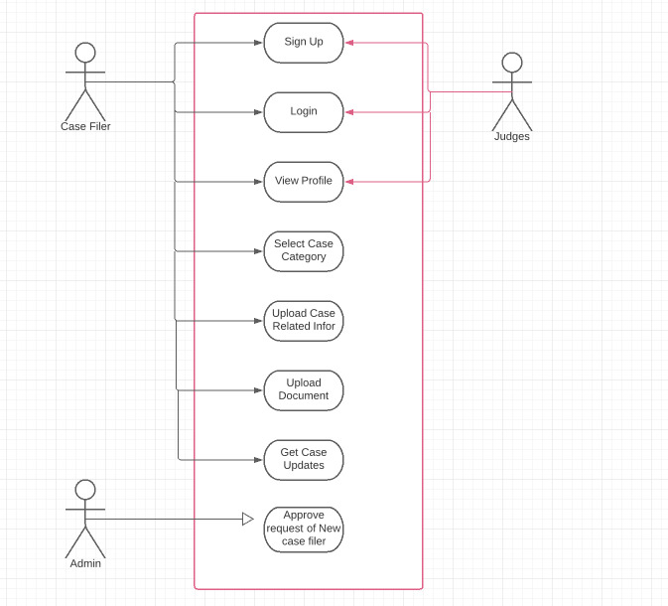**Figure 2 Use Case Diagram**

**Activity Diagrams:**

Activity diagram is basically a flowchart to represent the flow from one activity to another activity. The control flow is drawn from one operation to another. This flow can be sequential, branched, or concurrent. Activity diagrams deal with all type of flow control by using different elements such as fork, join, etc.

Activity diagram of Case Filer:-

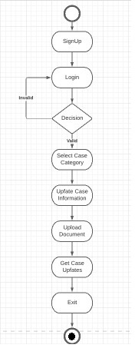

**Figure 3 Activity Diagram of Case Filer**

Activity diagram of Judge:-

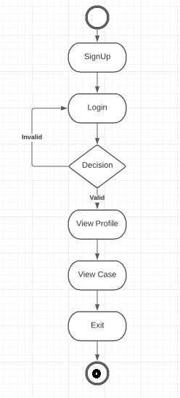

**Figure 4 Activity Diagram of Judge**

Activity diagram of Admin:-

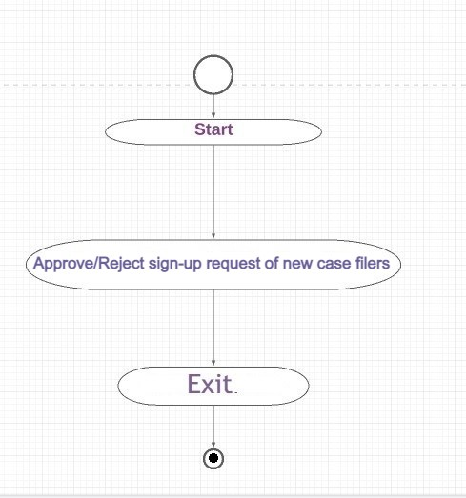

**Figure 5 Activity Diagram of Admin**

**Context / Zero level Diagram:**

A context diagram defines the boundary between the [system](https://en.wikipedia.org/wiki/System), or part of a system, and its environment, showing the entities that interact with it**.** It is used to establish the context and boundaries of the system to be modeled that which things are inside and outside of the system being modeled, and what is the relationship of the system with these external entities. A context diagram is also knows as a level 0 data-flow diagram.

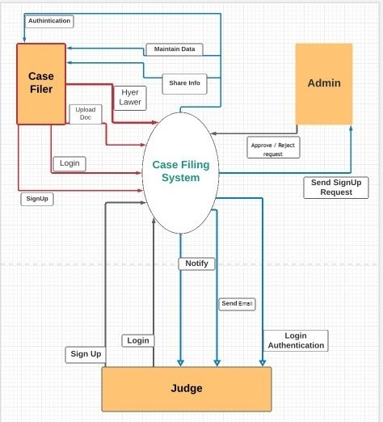

**Figure 6 Context Diagram of Case Filing System**